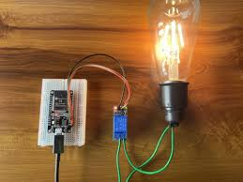

Write up
  - ESP32 LIGHT AUTOMATION
AJITH BIJU |ESP32 PROJECT| 21/05/2026
ESP32 Based IoT Home Automation Project Report 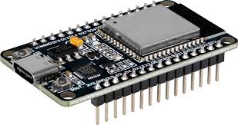
Introduction
The rapid development of Internet of Things (IoT) technology has changed traditional electrical systems into smart and automated systems that can be controlled remotely. This project explains the design and implementation of an IoT-based smart light control system using ESP32 and the Blynk cloud platform. The system allows users to control an electrical bulb remotely using a mobile application through wireless internet communication.
In this project, the ESP32 acts as the main controller and edge computing device, while the relay module is used to safely control the bulb. The main significance of this project is that it improves convenience and reduces manual effort by enabling remote appliance control. It also helps in energy efficiency because appliances can be monitored and controlled easily. Nowadays, similar technologies are widely used in smart homes, industries, security systems, and modern automation applications. This project also provides practical knowledge about how IoT devices communicate with cloud platforms in real time
.
1. IoT (Internet Of Things)
Internet of Things (IoT) is a modern technology in which physical devices are connected to the internet to collect, exchange, and process data automatically. These devices communicate with each other using sensors, microcontrollers, communication networks, and cloud platforms without requiring continuous human interaction.

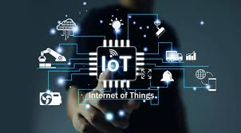
In this project:
- The ESP32 acts as the IoT device.
- The Blynk application acts as the user interface.
- Wi-Fi provides internet connectivity.
- The relay module controls the bulb.
IoT Architecture of the Project
1. Device-to-Device (D2D)
In this devices communicate directly with each other.
No cloud is required sometimes.
Example:- Bluetooth ,Zigbee ,Wi-Fi Direct
2. Device-to-Cloud
In thisDevices connect directly to cloud servers through internet.
Example:-Wi-Fi ,GSM ,Ethernet
3. Device-to-Gateway
Devices communicate through a gateway device.
Gateway acts like a middleman.
example:-Smartphone, Router, Raspberry Pi

Layers of IoT Architecture
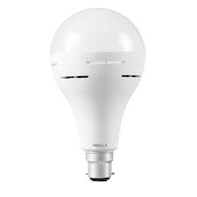
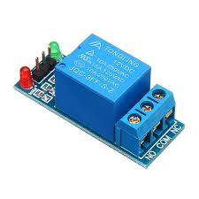
1. Device Layer
This layer contains:
ESP32 microcontroller
Relay module
Bulb
The ESP32 collects commands from the cloud and controls the relay accordingly.
2. Network Layer
This layer handles communication between devices using:
Wi-Fi
TCP/IP protocol
The ESP32 connects to the local Wi-Fi router and exchanges data with the Blynk cloud server.
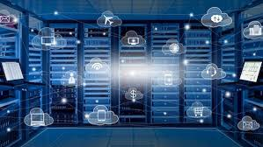
3. Cloud Layer
The Blynk cloud server:
Stores device information
Transfers commands between mobile app and ESP32
Maintains communication sessions
4. Application Layer
The Blynk mobile application or web console allows the user to:
Turn the bulb ON/OFF
Monitor device can be used remotely

OSI System and IoT
The OSI (Open Systems Interconnection) model is a framework used to explain how data travels from one device to another through a network.
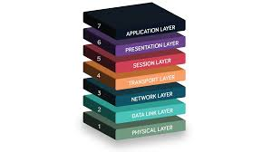
It divides communication into 7 layers so networking becomes easy to understand and troubleshoot.
7 Layers of OSI Model
1. Physical Layer
This layer sends raw electrical signals or wireless signals.
Example
Electrical signals traveling through Ethernet cable.
2. Data Link Layer
This layer checks whether data goes to the correct nearby device.
It Uses MAC addresses to communicate to communicate with each other.it is a unique code that is implanted in device.
3. Network Layer
This layer decides the path for data.
Uses:-IP addresses ,Routing
Example-Routers
4.Transport Layer
This layer ensures complete and correct delivery.
Protocols used-TCP UDP
- Session Layer
This layer creates and manages connection between devices.
Example
Maintains connection during video call.
- Presentation Layer
This layer converts data into readable format.
Example
Converting data into readable format.
- Application Layer
It is the application that is used by people
Examples-Email, WhatsApp etc
Data transmission using OSI model
1.APPLICATION LAYER
It is used by applications which use network to communicate.


For example:-
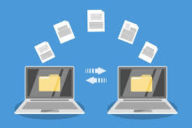

There are many application protocols that is used for various purpose .All these protocols forms the application layer.
For ex:-file transfer uses ftp protocol
Web searching uses http/https protocol
Emails:-smtp protocol
2.Presentation layer
Presentation layer receives data from application layer. This data is in the form of characters or numbers.
Ex:-hello,25haf
translation
In this layer these characters and numbers are converted into binary numbers which the computer could understand. For ex:-Hi to 11001000 11001001
This process is called translation
compression
11001000 11001001 can be reduced into small number of bits 11001001.this process is called data compression
It reduces the size of the data and helps to transfer data faster.
Ex-10mb data is reduced to 5mb
Therefore, it can be used for real time video and audio streaming
Encryption/decryption
To maintain the integrity of data before transmission data is encrypted.it enhances the security of data.
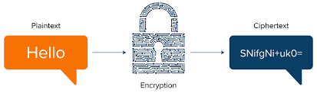
In sender side data is encrypted and in receiver side data is decrypted
This encryption/decryption uses SSL protocol(secure sockets layer)

3.Session layer
Session layer uses APIs(application programming interfaces)
NETBIOS is an example of APIs which allow applications to communicate which each other
Before a session is established ,server performs a function called authentication.
It is a process of verifying who you are .for this it uses a user name and password. If it is matched a session is established between the client and the server
Next the authorization is checked.it is used to determine that if the user have the permission to access the file.
It keeps the track of the file that are downloaded.
For example-when u access a data from a web page it keeps track of the file that u r accessing
4.Transport layer
It controls the reliability of communication through segmentation, flow control, error control .
Segmentation
In segmentation data received from session layer is divided into small data unit called data packets.
Each data packet has a source and destination port number and sequence number
Port number helps to direct the packets to the required application
Sequence number helps to reassemble the packets in the correct order.
For example:-data packet 1
Data packet 2
Data packet 3

Flow control
It controls the amount of data transmitted to a level receiver can process
For example:-when a mobile is connected toa server .here sever can transmit data at 100mbps and mobile can process data at 10mbps .here the mobile with the help of the transport layer can request the server to send the data at 10mbps.
Error control
If some data packet doesn’t reach the destination transport layer uses automatic repeat request to retransmit the lost data packet.
It uses protocols like:-
Transmission control protocol(TCP):-it performs connection-oriented transmission
User datagram protocol(UPD):-it performs connectionless transmission
UDP is faster than TCP because it doesn’t have feedback.
5.Network layer
It is used for transmitting of a data packet from one device to another located in different networks. Each segment in network layer is called data packet.
Here we use routers for communication
The functions of networking layers are:-
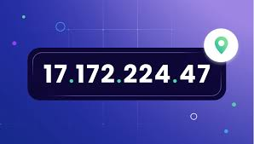
Logical addressing
Ip addressing done in logical layer are called logical addressing. Every computer connected to a network have a unique Ip address.in this layer it assigns sender and receiver Ip address each data packet so that it ensures the data packet is sent and received correctly
Routing
It is a method of moving a data packet from source to destination

For example:-if we need to access YouTube, we send request and the router checks the source and destination Ip address to deliver the item.

Path determination
A computer connected to network can deliver data in many ways. Choosing the best path for determination is called path determination
It uses protocols like :-OSFP (open shortest path first),BGP (border gateway protocol)to determine best path to deliver data.
6.Data link layer
it receives data packet from the network layer which contain the Ip address of sender and the receiver
there are two types of addressing:-
logical addressing
it is done at network layer where we assign sender and receiver Ip address to each data packet
physical addressing
physical addressing is done at the data link layer where mac address of both the devices is assigned to each data packet.
mac address is unique code embedded in the NIC pf the computer when it is manufactured.
The NIC is used to transfer data from one computer to anther through a local media. Local media radio signals used for means the copper wire fiber cables radio signals used for transmission.
7.Physical layer
Physical layer is used for converting the binary sequence into signals and transmit over local media.it can be electrical ,light or radio signals.
Signal generated by the physical layer depend on the type of media used to connect two devices
At the receiver ,the physical layer receives signal convert it into bits and pass it to data link layer as a frame and the to higher layers finally to the application layer. application layer protocol makes the senders message visible in the application in the receiver’s computer screen.
Example
When a user sends an email through Gmail, the data passes through all the OSI layers from the sender’s device to the receiver’s device. Each layer performs a specific function to ensure the message reaches correctly and securely.
1. Application Layer
The process starts at the application layer.
When a user types an email in Gmail and clicks Send, the application layer prepares the email data for transmission.
Protocols used:
HTTP/HTTPS for web access
SMTP (Simple Mail Transfer Protocol) for sending emails
For example:
User types: Hi
The application layer passes this message to the next layer.
2. Presentation Layer
The presentation layer handles:
Translation
Compression
Encryption
Translation
The text message is converted into binary form that the computer understands.
Example: Hi to Binary format
Compression
The binary data is compressed to reduce the size of the data.
Example:
10 MB file to compressed to 5 MB
Encryption
Before transmission, Gmail encrypts the data for security.
The encrypted data is then passed to the session layer.
3. Session Layer
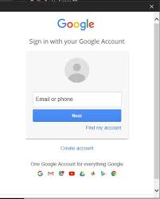
The session layer establishes and manages communication between the sender and the Gmail server.
Authentication
The Gmail server checks:
Username
Password
If correct, a session is created between:
Client (user device)
Gmail server
Authorization
The server checks whether the user has permission to access the Gmail account.
Session Management
The session layer keeps track of:
Sent mails
Downloaded attachments
Active communication
APIs such as NetBIOS help applications communicate.
After the session is established, data moves to the transport layer.
4. Transport Layer
The transport layer ensures reliable communication.
Segmentation
The email data is divided into small units called packets.
For Example:
Packet 1
Packet 2
Packet 3
Each packet contains:
Source port number
Destination port number
Sequence number
Port Number
Helps deliver packets to the correct application.
For Example:
Gmail application port
Sequence Number
Helps rearrange packets in correct order at the receiver side.
Flow Control
Controls transmission speed.
For Example:
Gmail server sends data at 100 Mbps
Mobile can process only 10 Mbps
Error Control
If packets are lost during transmission, they are retransmitted using:
Automatic Repeat Request (ARQ)
Protocols used:
TCP (Transmission Control Protocol)
UDP (User Datagram Protocol)
Gmail mainly uses TCP because emails require reliable delivery.
Then the packets move to the network layer.
5. Network Layer
The network layer sends packets between different networks.
Logical Addressing
Each device connected to the internet has a unique IP address.
For Example:
Sender IP address
Receiver IP address
The network layer adds these IP addresses to each packet.
Routing
Routers forward packets from one network to another.
For Example:
When sending Gmail:
Data travels through multiple routers on the internet.
Path Determination
There can be many paths between sender and receiver.
The router chooses the best path using protocols like:
OSPF
BGP
After routing, packets move to the data link layer.

6. Data Link Layer
The data link layer handles communication within the local network.
It adds physical addresses called MAC addresses.
Physical Addressing
Every device has a unique MAC address stored inside the NIC (Network Interface Card).
The data link layer adds:
Sender MAC address
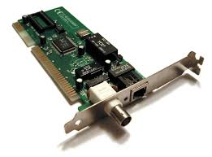
Receiver MAC address
NIC
NIC transfers data through:
Copper cables
Fiber optic cables
Radio signals (Wi-Fi)
At this layer, the data packet is called a frame.
Then the frame moves to the physical layer.

7. Physical Layer
The physical layer converts binary data into signals.
The signals travel through the communication medium to the receiver device.

Receiver Side Process
When the receiver opens Gmail:
- Physical layer receives signals and converts them into bits.
- Data link layer checks MAC address.
- Network layer checks IP address.
- Transport layer rearranges packets using sequence numbers.
- Session layer maintains communication session.
- Presentation layer decrypts and decompresses data.
- Application layer displays the email message in Gmail.
Finally, the receiver sees:
Hi on the screen.
2. ESP32 Usage in the Project
The ESP32 is used as the main edge computing device in the project to process commands, control the relay module, connect to Wi-Fi, and enable real-time communication between the hardware system and the Blynk cloud platform.
3. Edge Computing Utilization
Edge Computing
Edge computing is a computing method in which data processing and decision-making occur near the physical device itself instead of depending entirely on distant cloud servers. This approach reduces delay, minimizes unnecessary internet communication, and improves overall system efficiency.
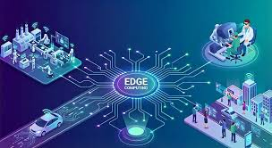
Server computing
Server computing refers to the processing and management of data using powerful remote servers connected through the internet. In IoT systems, cloud servers are used to store information, manage communication, and transfer data between devices and users.

4. Edge Computing Analysis
Advantages
1. Faster Response
2. Reduced Internet Dependency
3. Lower Cloud Processing
4. Reduced Bandwidth Usage

5. Latency and Overhead
Latency
Latency refers to the time delay between a user action and the actual response of the device. In IoT systems, lower latency is extremely important for achieving fast and smooth real-time operation.

In This Project Latency occurs during:
Internet communication
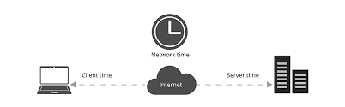
Wi-Fi transmission
Cloud server processing
Factors Affecting Latency
Internet speed
Wi-Fi signal strength
Server response time
Overhead
Overhead refers to the extra communication and processing resources required for transmitting data in a network system.
Types of Overhead
Network overhead
Protocol overhead
Memory overhead
Processing overhead
Overhead in the Project
Examples:
Wi-Fi packet transmission
TCP/IP headers
Authentication tokens
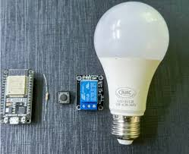
6. Hardware Division
Hardware Components
components | function
ESP32 | Main controller
Relay module | Switches AC bulb
Blulb | Output Device
Jumper Wire | connections
Breadboard | Circuit assembly
Power Supply | Power ESP32

7. Software Division
Software Components
Software | Purpose
Arduino IDE | Programming ESP32
Blynk IOT | Mobile Interface
ESP32 Board package | ESP32 programming support
Blynk Library | Cloud communication
WiFi Library | Internet connectivity

8. Communication Protocols
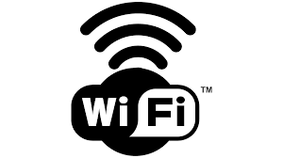
Wi-Fi Protocol
It is a protocol used for wiFi communication
It is used for:-
1.Wireless connectivity
2.Internet communication
3.Cloud access

TCP/IP Protocol
TCP/IP is used to communication between devices.

9. Program
Complete Program Structure
#define BLYNK_PRINT Serial
#define BLYNK_TEMPLATE_ID"TMPL3zlGeCC9M"
#define BLYNK_TEMPLATE_NAME"light iot"
#define BLYNK_AUTH_TOKEN"RvQhItYi4Vndytf80_ZB4e29lNLj85pT"
#include <WiFi.h>
#include <WiFiClient.h>
#include <BlynkSimpleEsp32.h>
char ssid[] = "Redmi 9 Power";
char pass[] = "password";
void setup()
{
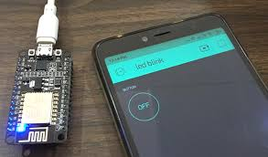
Serial.begin(9600);
Blynk.begin(BLYNK_AUTH_TOKEN, ssid, pass);
}
void loop()
{
Blynk.run();
}
10.Program explanation
#define BLYNK_PRINT Serial
- This line enables debugging messages from the Blynk library to be displayed on the Serial Monitor. It helps in checking connection status and errors.
#define BLYNK_TEMPLATE_ID "TMPL3zlGeCC9M"
- This defines the unique Template ID created in the Blynk cloud platform. It identifies the IoT project template.
#define BLYNK_TEMPLATE_NAME "light iot"
- This defines the name of the Blynk template used for the project.
#define BLYNK_AUTH_TOKEN "RvQhItYi4Vndytf80_ZB4e29lNLj85pT"
- This line stores the authentication token provided by Blynk. The token allows the ESP32 to securely connect to the Blynk cloud server.
#include <WiFi.h>
- This header file enables Wi-Fi functionality in the ESP32 and allows connection to wireless networks.
#include <WiFiClient.h>
- This library provides TCP/IP client functions for internet communication between the ESP32 and cloud server.
#include <BlynkSimpleEsp32.h>
- This library contains all functions required for connecting the ESP32 to the Blynk IoT platform.
char ssid[] = "Redmi 9 Power";
- This stores the Wi-Fi network name (SSID) that the ESP32 will connect to.
char pass[] = "password";
- This stores the password of the Wi-Fi network.
void setup()
- The setup() function runs only once when the ESP32 powers ON or resets. It is used for initialization.

Serial.begin(9600);
- Starts serial communication at 9600 baud rate. It allows communication between the ESP32 and the computer through the Serial Monitor.
Blynk.begin(BLYNK_AUTH_TOKEN, ssid, pass);
- This connects the ESP32 to:
- Wi-Fi network
- Blynk cloud server
- using the authentication token, Wi-Fi name, and password.
void loop()
- The loop() function runs continuously after the setup function completes.
Blynk.run();
- This continuously maintains communication between the ESP32 and the Blynk cloud server. It checks for commands from the mobile application.
Advantages of the Project
Energy saving
Real-time operation
Wireless operation

11.Circuit diagram
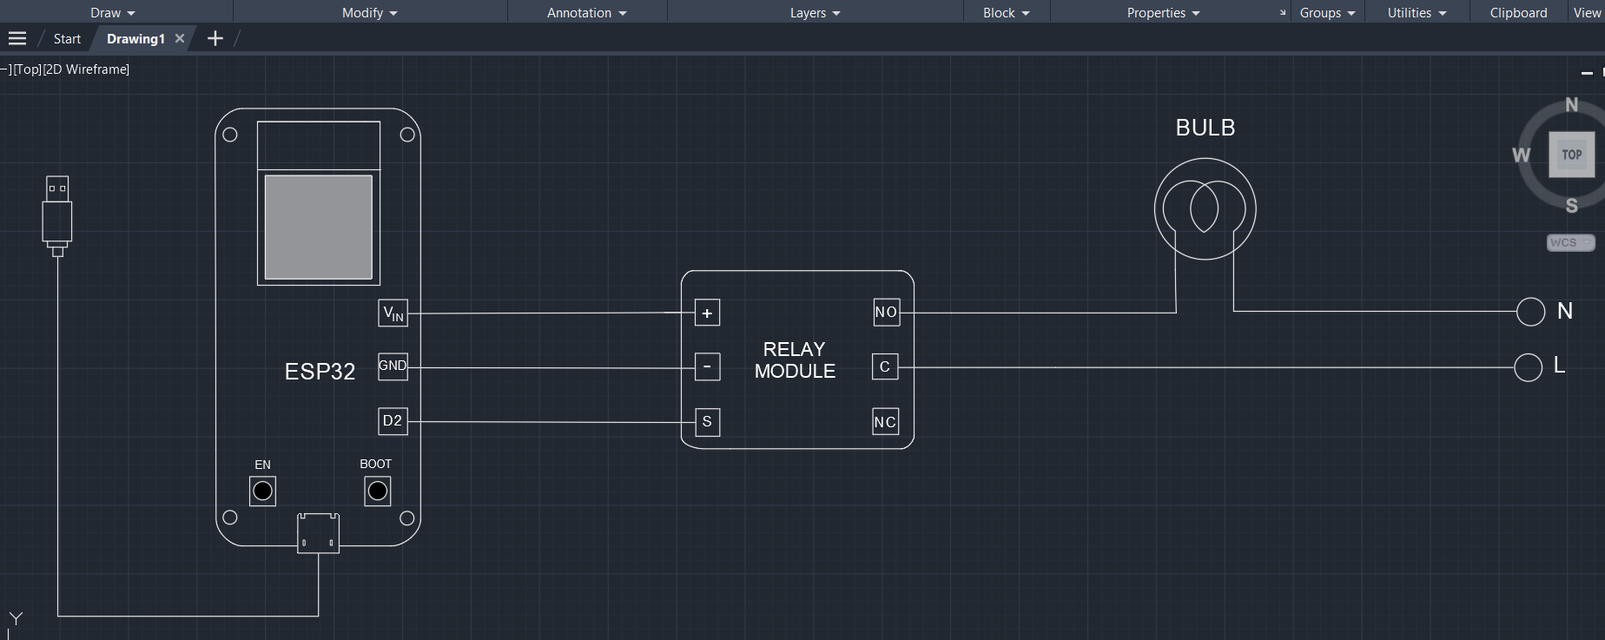
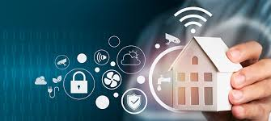
12.ESP Can be used for:-
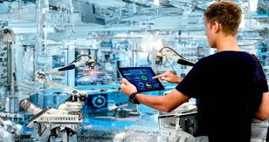
Smart homes
Industrial automation
Smart lighting systems
Remote monitoring systems
IoT learning projects
13. Conclusion
This ESP32-based IoT home automation project successfully demonstrates the implementation of a smart wireless lighting control system using modern IoT technologies. The integration of ESP32, relay module, Wi-Fi communication, and the Blynk cloud platform enables real-time remote appliance control through a mobile application.

